PNEUMONIA DETECTION USING DEEP LEARNING
Methodology, Novelty and Key Contributions
Department of Computer Science and Engineering, TKR College of Engineering and Technology (Autonomous)
Batch A12 (CSE-A) · Academic year 2026-2027
Table 1: Project team
S.No. | Student name | Roll number
1 | CHOUDAM AKSHITHA | 23K91A0556
2 | BOGGULA SATVIK KUMAR | 23K91A0541
3 | ARUTLA ABHI THEJ REDDY | 23K91A0515
4 | DUGGARAJU LIKHITHA | 23K91A0565

Project guide: V. MEENAKSHI
Chapter and section numbers quoted in the text (for example Section 6.6 or Chapter 8) refer to the full project report, 17.Final Document. Figures and tables in this document are numbered from 1.

1. OVERVIEW OF THE METHODOLOGY
This document describes how the system works from end to end and what is new in it. Part 1 gives the pipeline, the data, the algorithms and the reasons they were chosen; Part 2 sets the work against the base paper and separates what is new from what is standard; Part 3 lists the contributions.

6.1 Overall methodology
The method has two phases that share one preprocessing function. In the training phase the public chest X-ray data are listed, labelled from their folder and file names, preprocessed, split by patient into training and validation parts, augmented and used to fit the CNN; the best weights are evaluated once on the untouched test split and every number is written to JSON. In the inference phase an uploaded image goes through the same preprocessing, the saved network returns three probabilities, Grad-CAM explains the arg-max class, and the result is stored and displayed.
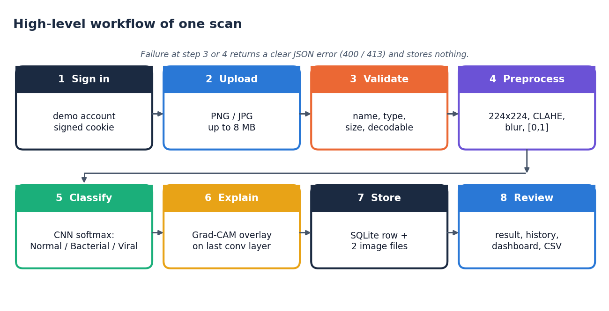
Figure 1: Overall workflow used at inference time (the same preprocessing is used for training)

6.2 Dataset
The data are the Chest X-Ray Images (Pneumonia) collection of Kermany et al. [3], [4]: paediatric (one to five years) anterior-posterior chest radiographs from the Guangzhou Women and Children's Medical Center, released under CC BY 4.0. The version used has 5,856 JPEG images in the official folders train (5,216), val (16) and test (624). Pneumonia images carry the pathogen in the file name (person12_bacteria_34.jpeg, person7_virus_21.jpeg), which gives the three project classes.
Table 2: Official folders and the three project classes
Folder | Normal | Bacterial | Viral | Total
train | 1,341 | 2,530 | 1,345 | 5,216
val | 8 | - | - | 16 (8 normal, 8 pneumonia)
test | 234 | 242 | 148 | 624

The official validation folder holds only 16 images, too few to guide training. The experiment script therefore merges train and val and cuts a validation set of about 10 % by patient (a stratified group split, seed 42), so that images of one patient never appear on both sides. The official test folder is used once, for the final evaluation. A further check (Section 8.4) shows that many pneumonia file ids in the test folder also occur in the training folders, a property of the public data that earlier work has also reported; the report therefore also gives results on the part of the test split that shares no id with training and on a fully patient-disjoint re-partition.
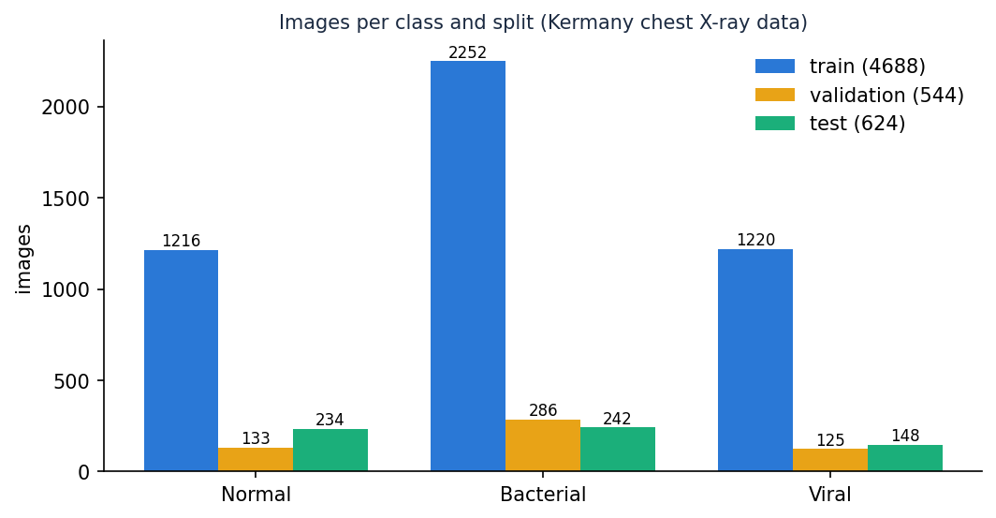
Figure 2: Images per class in the training, validation and test sets used by the main experiment

6.3 Preprocessing
The function load_and_preprocess_image in model/preprocess.py is used unchanged by the training script, the Flask route and the FastAPI route:
1. Decode the file as a single-channel grayscale image (cv2.imread or cv2.imdecode); a file that cannot be decoded raises ValueError, which the API turns into HTTP 400.
2. Resize to 224 x 224 with area interpolation, the input size of the network and of the ImageNet backbones.
3. Apply CLAHE, contrast-limited adaptive histogram equalisation [11], with clip limit 2.5 and 8 x 8 tiles, to bring out lung markings.
4. Apply a 3 x 3 Gaussian blur to suppress scanner and JPEG noise.
5. Replicate the channel three times and divide by 255 to obtain a float32 tensor in [0, 1] of shape 224 x 224 x 3.
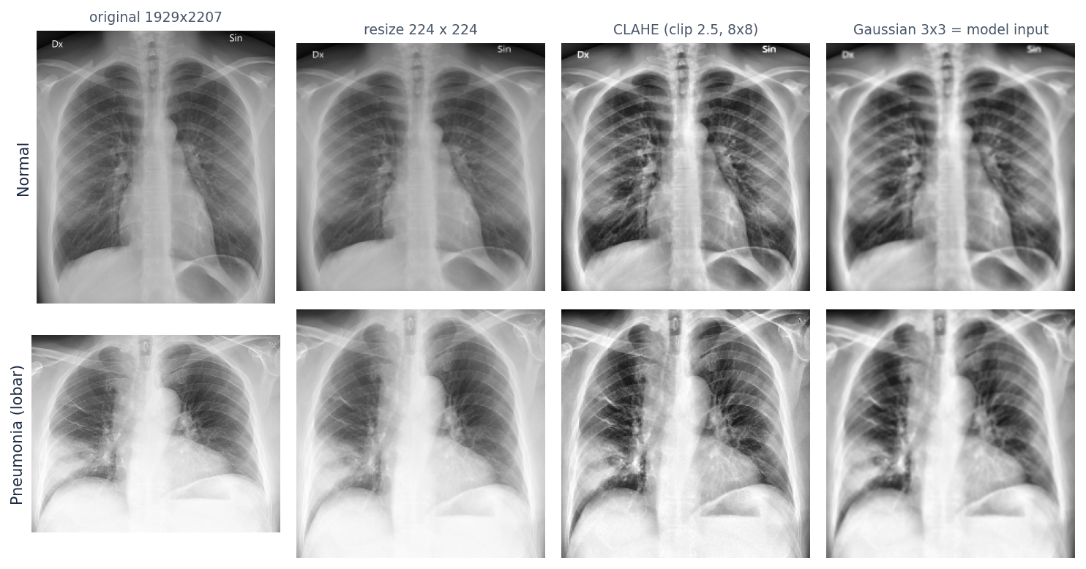
Figure 3: Preprocessing steps applied to a normal and a pneumonia radiograph (public-domain sample images)
During training, augmentation is applied on top of the preprocessed image: rotation up to 12 degrees, horizontal and vertical shifts of 8 %, shear of 8 %, zoom of 12 % and horizontal flips, with nearest-neighbour filling. These are the ranges of get_train_augmentor in the original code. The base paper disables flips to preserve anatomical orientation [1]; the project's augmentor keeps them, which is recorded as a design difference.

6.4 Algorithm choice and justification
Table 3: Choices and reasons
Decision | Choice | Reason
Model family | CNN written for the project (4 convolution blocks) | Small (0.59 M parameters), trains on a CPU, no external weights, easy to explain; a transfer-learning builder is also provided
Normalisation | Batch normalisation after each convolution | Stabilises training of a network trained from scratch [17]
Pooling before the head | Global average pooling | Fewer parameters than flattening and keeps spatial meaning for Grad-CAM
Regularisation | Dropout 0.35 and 0.25, data augmentation, early stopping | Small data and a risk of over-fitting [18]
Loss | Categorical cross-entropy with balanced class weights | Bacterial images are about twice as frequent as the other classes
Optimiser | Adam, learning rate 3e-4 (baseline run: 1e-4) | Adaptive and robust for a first experiment [16]
Explanation | Grad-CAM on the last convolution layer | Works on any CNN without changing it [9]; the layer is named last_conv
Contrast step | CLAHE | Standard for radiographs [11]; its effect is measured by an ablation (Chapter 8)

6.5 Mathematical formulation
Convolution block. For the input feature map A(l-1), learned kernels W(l) and biases b(l), each block applies a convolution, the ReLU non-linearity, batch normalisation and 2 x 2 max pooling.
A(l) = MaxPool( BN( ReLU( W(l) * A(l-1) + b(l) ) ) ), ReLU(x) = max(0, x) (1)
BN(x) = γ · (x − μB) / √(σB² + ε) + β (2)
Classifier. Global average pooling turns each of the 256 final feature maps into one number; two dense layers follow and the output layer produces three logits z, which the softmax converts into probabilities. The predicted class is the arg-max and the reported confidence is its probability.
gk = (1 / HW) · Σi Σj Ak(i, j) (3)
pc = exp(zc) / Σj=1..3 exp(zj), ĉ = argmax pc, confidence = pĉ (4)
Loss. With balanced class weights (N images, K = 3 classes, nc images in class c) the weighted cross-entropy over a batch of B images is:
wc = N / (K · nc) (5)
L = − (1 / B) · Σi=1..B w(yi) · Σc yic · log pic (6)
Optimiser. Adam keeps exponential moving averages of the gradient (mt) and of its square (vt) and updates the parameters with learning rate η (3 × 10-4 for the deployed model, 10-4 for the baseline run):
θt = θt-1 − η · m̂t / ( √v̂t + ε ) (7)
Grad-CAM. For class c and the last convolutional feature maps Ak, the channel weights are the spatially averaged gradients of the class score, and the map is the rectified weighted sum of the feature maps, normalised by its maximum, resized to 224 x 224, coloured with the JET colour map H and blended with the display image I (code: overlay_heatmap, alpha 0.4):
αkc = (1 / Z) · Σi Σj ∂yc / ∂Ak(i, j), Lc = ReLU( Σk αkc · Ak ) (8)
O = 0.6 · I + 0.4 · H (9)
Metrics. From the confusion matrix, with TP, TN, FP and FN counted for the class (or for pneumonia against normal in the binary view):
accuracy = (TP + TN) / N, precision = TP / (TP + FP), recall = sensitivity = TP / (TP + FN) (10)
specificity = TN / (TN + FP), F1 = 2 · precision · recall / (precision + recall), macro-F1 = mean of the three class F1 (11)
Calibration is summarised by the expected calibration error with M = 10 equal-width confidence bins [29], where acc(Bm) and conf(Bm) are the accuracy and mean confidence of the images in bin m. A confidence threshold τ keeps a prediction for automatic reporting only if its confidence is at least τ; coverage is the share of scans kept:
ECE = Σm=1..M (|Bm| / n) · | acc(Bm) − conf(Bm) |, coverage(τ) = #{ i : pĉ,i ≥ τ } / n (12)

6.6 Model architecture and training
The deployed architecture is build_custom_cnn from model/model_builder.py. The input is 224 x 224 x 3. Four convolution blocks (3 x 3 kernels with 32, 64, 128 and 256 filters, each followed by batch normalisation and 2 x 2 max pooling) are followed by global average pooling, a 512-unit dense layer with batch normalisation and dropout 0.35, a 128-unit dense layer with dropout 0.25 and a three-unit softmax output. The last convolution layer is named last_conv so that Grad-CAM can find it.
Table 4: Layers of the deployed network
Layer | Type | Output shape | Parameters
input_layer | InputLayer | 224x224x3 | 0
conv2d | Conv2D | 224x224x32 | 896
batch_normalization | BatchNormalization | 224x224x32 | 128
max_pooling2d | MaxPooling2D | 112x112x32 | 0
conv2d_1 | Conv2D | 112x112x64 | 18,496
batch_normalization_1 | BatchNormalization | 112x112x64 | 256
max_pooling2d_1 | MaxPooling2D | 56x56x64 | 0
conv2d_2 | Conv2D | 56x56x128 | 73,856
batch_normalization_2 | BatchNormalization | 56x56x128 | 512
max_pooling2d_2 | MaxPooling2D | 28x28x128 | 0
last_conv | Conv2D | 28x28x256 | 295,168
batch_normalization_3 | BatchNormalization | 28x28x256 | 1,024
max_pooling2d_3 | MaxPooling2D | 14x14x256 | 0
global_average_pooling2d | GlobalAveragePooling2D | 256 | 0
dense | Dense | 512 | 131,584
batch_normalization_4 | BatchNormalization | 512 | 2,048
dropout | Dropout | 512 | 0
dense_1 | Dense | 128 | 65,664
dropout_1 | Dropout | 128 | 0
dense_2 | Dense | 3 | 387

The network has 590,019 parameters (588,035 trainable), about 2.36 MB in 32-bit floats.
The original model/train.py fits the same network with a Keras directory generator and rescaling only. The experiment script scripts/train_experiment.py (used for every number in this report) differs in four ways: it applies the inference preprocessing (CLAHE and blur) during training, so the network is trained on what it will see in service; it splits validation data by patient; it uses balanced class weights; and it records metrics, predictions and figures.
Table 5: Training configuration of the main experiment
Setting | Value
Architecture | build_custom_cnn(num_classes=3)
Input | 224 x 224 x 3, CLAHE + blur preprocessing
Optimiser / loss | Adam, learning rate 0.0003; categorical cross-entropy with balanced class weights
Batch size / maximum epochs | 32 / 40
Callbacks | Early stopping on validation loss (patience 10, best weights restored); learning rate halved after 3 epochs without improvement
Augmentation | Rotation 12, shift 0.08, shear 0.08, zoom 0.12, horizontal flip
Random seed | 42
Hardware | Intel Core i5-12500 CPU, no GPU; about 214 seconds per epoch

Baseline run and recipe change (disclosure). The first run used the project's defaults (Adam 1e-4, early-stopping patience 6, at most 25 epochs). It stopped after 12 epochs with its best validation loss at epoch 6: the validation loss of a batch-normalised network trained from scratch is noisy, early stopping fired before the network had converged, and training accuracy was only about 74 %. The recipe was then changed to a higher learning rate (3e-4), a longer patience (10) and up to 40 epochs. This change was made after the baseline's test result had been seen, so both runs are reported side by side (Section 8.5); the choice of the deployed model between them rests on the validation set, not on the test split.
Transfer-learning option and a limitation found while testing it. build_transfer_model offers DenseNet201, DenseNet121, ResNet152V2 and EfficientNetB0 backbones. When a backbone is nested inside the model, make_gradcam_heatmap cannot connect the nested feature tensor to the outer input and raises an error; the shipped Grad-CAM therefore works only with the flat custom CNN, which is why the custom CNN is the deployed model. Chapter 8 includes a MobileNetV3Small experiment (the base paper's backbone) for comparison, without Grad-CAM.

2. NOVELTY AGAINST THE BASE PAPER
The base paper [1] is a research study of lightweight networks and semi-supervised learning. This project does not try to beat its benchmark numbers; its contribution is of a different kind. The table separates what is new in this work from what is standard practice that it reuses.
Table 6: Novelty against the base paper
Aspect | Base paper | This project | Novel here?
Output classes | Normal / Pneumonia, and a 4-class multi-disease set | Normal / Bacterial / Viral pneumonia (pathogen type) | Different task; pathogen type is harder and less studied
Deliverable | Experimental framework | End-to-end web application: login, upload, prediction, heat map, history, dashboard, export, tests | Yes: the main contribution
Train/serve consistency | Models pre-processed with the MobileNetV3 function | One preprocessing function (CLAHE + blur) shared by training, Flask and FastAPI; the original train.py lacked CLAHE | Yes: found and fixed in the experiment script
Validation design | Balanced random subsets, seed 42 | Patient-level validation split; second protocol re-partitions all data by patient | Partly: adopts good practice from [6]
Test-set hygiene | Not discussed | Counts how many official test images share an id with training and reports an id-disjoint subset | Yes for this project; the issue itself was raised in [6]
Uncertainty | Monte Carlo Dropout, TTA, ECE | ECE and a confidence-threshold analysis (no MC Dropout) | Simpler; not a novelty
Explanation | Grad-CAM on test images | Grad-CAM generated and stored for every scan, shown next to the image | Application of a standard method
Semi-supervised learning | FixMatch, FlexMatch, FreeMatch | Not used | Not reproduced
Architecture | MobileNet family | Compact custom CNN; MobileNetV3Small compared as a baseline | Standard components

What is not new. CLAHE, batch-normalised CNNs, Grad-CAM, class-weighted cross-entropy and patient-level splitting are all established techniques, and the dataset is public. The project's value lies in combining them into one reproducible, tested and inspectable system, and in reporting its performance with the protocol stated.

3. KEY CONTRIBUTIONS
The contributions of the project, in order of importance:
1. A complete, runnable pipeline from upload to explained prediction: validation, CLAHE-based preprocessing, a three-class CNN, a Grad-CAM overlay and persistent history.
2. A training and evaluation procedure (scripts/train_experiment.py) that uses the same preprocessing function at training and inference time, splits validation data by patient to avoid leakage, and writes every metric to JSON.
3. A measured baseline for the project's own architecture on the public Kermany test split, including a three-class confusion matrix, a Normal-versus-pneumonia view, calibration error, a confidence-threshold analysis and an ablation of the CLAHE step.
4. A thin API layer and a new React front end over the existing Flask project, with a demo login, dashboard, history search, export and printable report, without changing the original model code.
5. An automated test suite and design documentation (ten diagrams) that make the system reproducible and reviewable.
6. A measured baseline: 79.5% three-class accuracy, 98.7% pneumonia sensitivity and 62.0% specificity on the official test split, with the patient-overlap caveat quantified.

